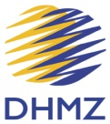

REPUBLIC OF CROATIA
Meteorological and Hydrological Service (DHMZ)

Report by the Director of DHMZ

Last year, 2014, and again 2015, will be remembered because of the several severe flooding events due to the high frequency of rain with the extreme amounts and resulting river level heights that exceeded 1000 years return period. The most severe one is related to the Sava River flooding that occurred in May 2014 near the border triple point of Croatia with Serbia and Bosnia and Herzegovina. In Croatia it has caused evacuation of about 20.000 people, about 300 MEUR damage and 3 casualties. Another flooding event was this year in October at Kupa and Mrežnica rivers basin, with the severe flooding at the town of Karlovac. The Meteorological and Hydrological Service (DHMZ) performance was well executed, including high coordination with the civil protection. In 2014 flooding there was strong support by the Slovenian NMHS (ARSO) in the vital segment of hydrological data and products, while this year, for the first time, it has been supported by the hydrological model products produced at the DHMZ. Thus, investment on the hydrological model - Mike 11 - implementation for the Sava and Kupa river basin was immediately utilized several days after the implementation at the early beginning of the experimental period. This all has resulted in a stronger strategic partnership with the State Directorate of Rescue and Protection and the Croatian Waters.

During September 2015 DHMZ has also put into the experimental operational phase the Flash Flood Guidance System - FFGS. This system is under the program Development and implementation of a Regional FFGS for South Eastern Europe in cooperation with WMO, Hydrologic Research Center and NOAA. Both systems, MIKE 11 and FFGS, are under the close cooperation of meteorologists and hydrologists and are proved as reliable and useful tools for hydrological forecast during recent flooding.

Considering its regular position, the DHMZ is following previous activities under the vigilance of the Ministry of Environmental and Nature Protection, with a particular sensitivity to the air quality monitoring. Despite the DRR successful performance, there is continuing process of the budget decrease and the stuff cut. The existing employment rule "2 out 1 in", what could be realized only at the vacant post left, is severely preventing proactive human resources management and enabling only reactive one.

Recognising this, the DHMZ has intensified: (1) commercial activities beyond 10 % of the total budget, (2) employment mechanism out of regular budget using the external agencies and also (3) intensified its stakeholder potential for its own capacity development. Thus, investment in the hydrological modelling is following expected milestones in a strong partnership with the Croatian Waters and the Slovenian Environment Agency (ARSO). Croatian Waters preserves the main strategic partner by securing the DHMZ commercial income up to the level up to 70%. DHMZ also continues to utilize Government funded mechanism of contracting young unemployed experts.

Nominally, the total budget has slightly raised from 13,4 to 14.2 M€, mostly due to the state investment for the additional air quality monitoring as well as some additional commercial activities. Actually, the budget for the core activities has slightly decreased, up to the 2.5 %. The most severe reduction in budget was related to the lack in full financial State support of the membership fees, particularly fee for EUMETSAT.

Luckily, this gap was compensated by the usage of the unforeseen income due to the penalties (including interests) to the local authorities (counties) because of their incomplete payment of the hail suppression activities to the DHMZ in the last three years, what was obligation by the Law. Additional potential benefit for the DHMZ of such pressure at the local authorities could be reflected in their reconsideration of the current full profile operative hail suppression performance along with their request to the Ministry of Agriculture to decrease their financial contribution with the consequent decrease of the hail suppression performance, hopefully through a rocket component cut. In our vision, this is foreseen to be a starting milestone of the solution of the problem related to more than 45 years hail suppression activity in Croatia. Shrinking of the hail suppression to ground generators will decrease expenses up to 50 % of the current ~2.5 M€. This would also enable human and technical resources management including displacement of 1 to 3 old radars at the Adriatic coast as a test-bed for the forthcoming EU 2016 - 2022 project that is supporting DHMZ meteorological infrastructure capacity development. The project is expected to be approved at the beginning of 2016 by the Government utilizing thus 24M€ EU structural fund +5 M€ as the obligatory contribution from the Croatian Government.

In the next few months, approvals of the several other EU funded projects are expected. One is related to the modernization of the air quality monitoring network. DHMZ also preserves beneficiary position at the EU forthcoming project on the hydrological infrastructure capacity development. The project is expected to be launched until the end of 2015 by the Croatian Waters - as the project leader. Just recently, DHMZ has made considerable progress in preparation of the vital importance project: realization of the new Headquarters building trough the EU structural fund. The progress is related to the position "right to build" as the necessary condition for the application to the EU structural fund guided by the Ministry of Science, Education and Sport.

DHMZ continues efforts to strengthen WIGOS character the WIS DCPC Marine Meteorological Centre for the Adriatic Sea Area by a closer engagement and strengthening partnership at the national level with the Croatian Hydrographic Institute, the Institute for Oceanography and Fisheries, Geophysical Department at the University of Zagreb, and the Institute Ruđer Bošković. Common working groups on marine observation and oceanographic modelling has been established and started performance up to agreed terms of reference.

DHMZ succeeded to maintain its ISO 17025 accreditation for several calibration methods under the performance of the Laboratory of Meteorological Instrument Calibration and the Chemical Laboratory and is on the way to finalize accreditation status as the Reference Laboratory for Air Quality Monitoring. This has particular importance for securing robust resistance towards permanent private sector treats as well as securing perception of credibility of the Service by the responsible Ministry.

DHMZ is continuing the most of the research and development activities and has also reconfirmed it status as the Scientific Unit at the Croatian Agency for Science and Higher Education. In 2014 the DHMZ has completed its engagement in the IPA 2012 Phase II Project “Building Resilience to Disasters in Western Balkans and Turkey” what has been guided by the WMO and the UNISDR. This year DHMZ has completed engagement in the IPA EU projects: (1) WILL4WIND - Weather Intelligence for Wind Energy, as a project leader, (2) ENHEMS - Enhancement of Research, Development and Technology Transfer Capacities in Energy Management System for Buildings, as a project partner, (3) ORIENTGATE related to the climate change adaptation in South Eastern Europe (including Italy, Austria, Hungary and Ukraine), as a project partner and (4) ADRIARADNET - Adriatic integrated Radar-based and web-oriented information processing system Network to support hydro-meteorological monitoring and civil protection decision, as the project implementation facilitator. There is the new EU HORIZON 2020 funded project: EU-CIRCLE - a pan-EUropean framework for strengthening Critical Infrastructure Resilience to CLimate changE”.

DHMZ is continuing its proactive involvement with the WMO (particularly RA VI activities), GEO, EMI entities as well as with ICCED / ICSEED, ALADIN / RC LACE, HyMeX, GCOS, JCOMM, IPCC, EMEP and International Sava River Basin Commission communities. This year DHMZ has also achieved to become a member of EUROGOOS. The hottest news is that the Croatian Parliament, just before ending of its mandate before the elections, at the its last session in September, ratified agreement with the ECMWF. There is a good chance that deposition of the document will be executed not latter then the beginning of December, thus enabling Croatia to become a full member of ECMWF from the 1st January 2016.
DHMZ continues active partnership with the Regional Instrument Centre in Ljubljana (Slovenia) and the Drought Management Centre for South-eastern Europe (DMCSEE). There were also fertile bilateral meetings with the Slovenian (ARSO) and Hungarian (OMSZ) NMHSs, as well as several others (Finish - FMI, Polish - IMGW and Swedish - SMHI). This year in May, DHMZ has the honour to host in Zagreb the WMO RA VI Workshop on SEB, and recently in Dubrovnik 42nd Session of the IPCC.
This November in Osijek, DHMZ is a co-organizer of the PannEx workshop with a goal to evaluate the potential for initiating an Global Energy and Water Exchanges Project and Regional Hydroclimate Project under the frame of the World Climate Research Programme over the Pannonian basin.
DHMZ still continues regular and active partnership with all kinds of media, particularly with the national radio and television.

Ivan Čačić, Director
PR of Croatia with WMO

ANNEX 1

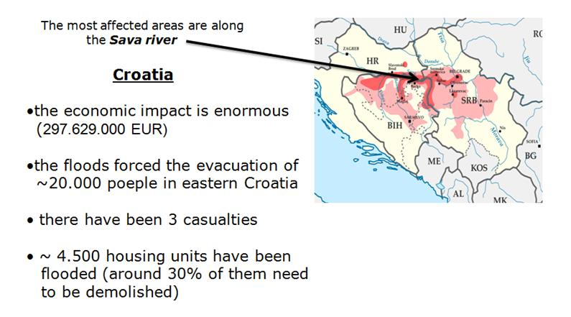

ANNEX 2

DHMZ meteorological, hydrological and related infrastructure

DHMZ is operating 41 main meteorological, 117 climatological, 336 precipitations and 23 rain storage, 12 background and 10 urban state air quality stations. Automated weather stations are co-located at 34 main meteorological station (MMS) sites, and 43 uncompleted automated weather stations are performing at other locations. DHMZ is also operating 452 hydrological stations for surface waters (83 are automatic stations owned and operated by the DHMZ, and 151 are overseen by the Croatian Waters) and 714 stations for ground water. DHMZ still takes care of the two radio-sounding systems in Zagreb and Zadar, 2 Doppler S band + 6 small S band weather radars and one sodar.

